1. Ranking by Mentions:

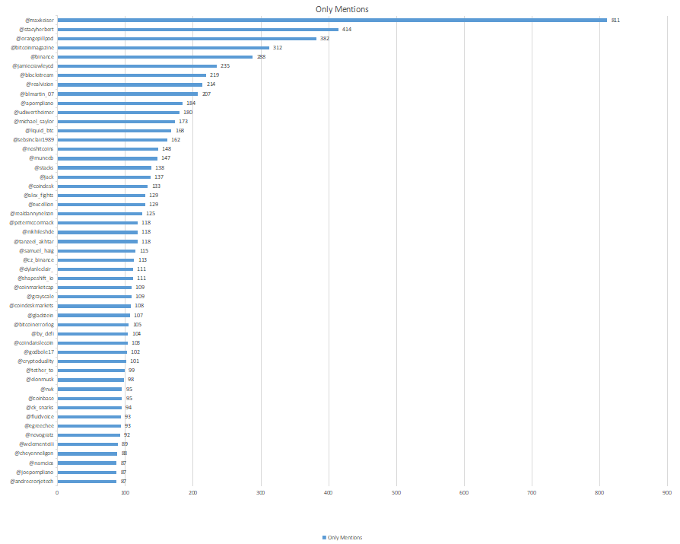

1. Ranking By Reputation

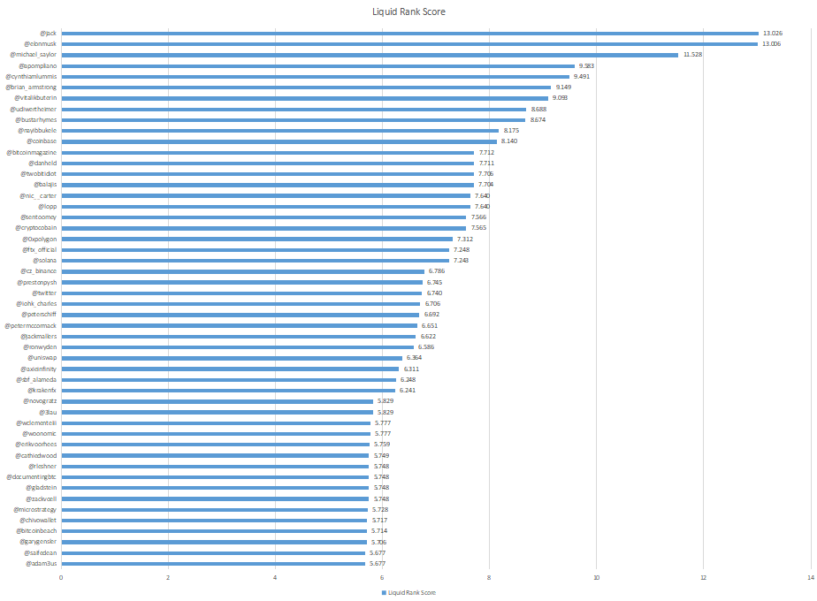

1. Ranking A\*B

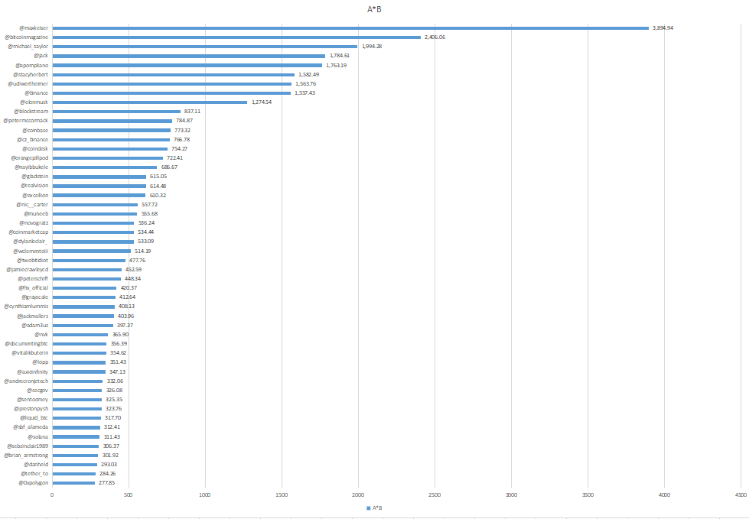

1. Decision Support

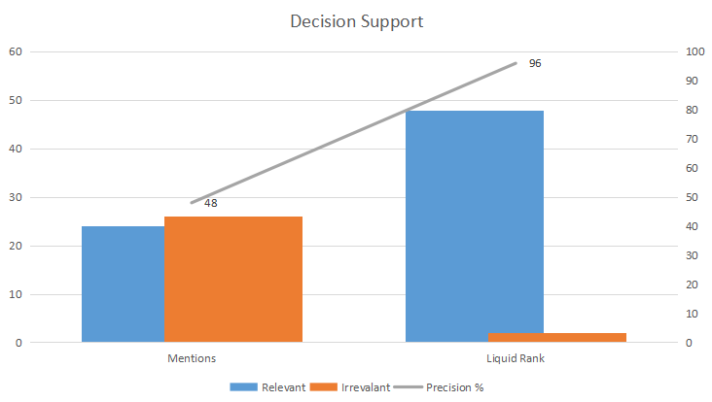

1. Average Precision Method (Mentions)

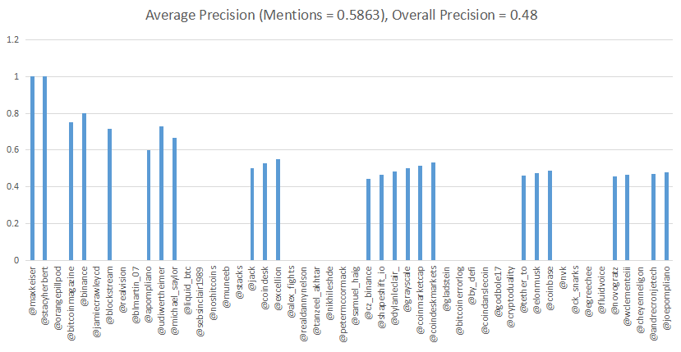

1. Average Precision Method (Liquid Ranking)

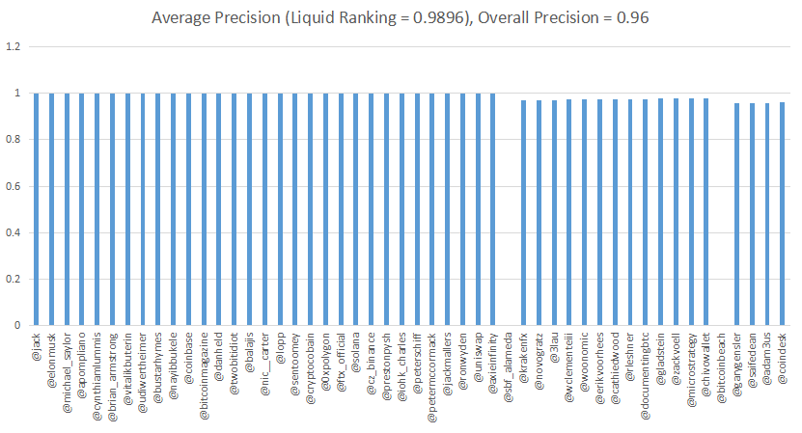

1. Mean Reciprocal Ranking (Mentions)

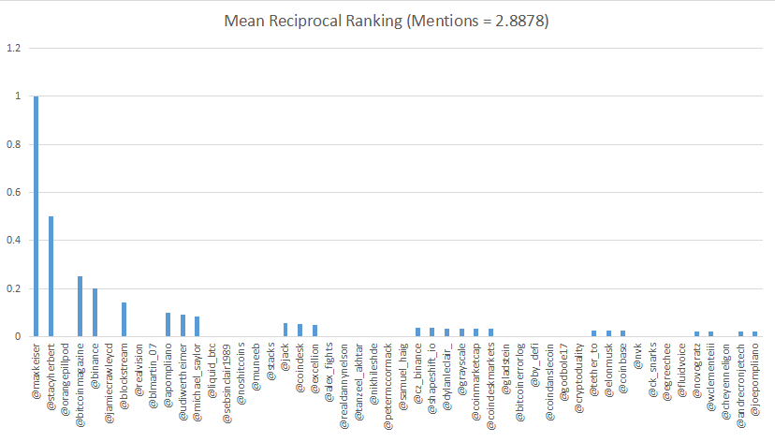

1. Mean Reciprocal Ranking (Liquid Ranking)

